**Advance Excel Assignment –9**

**By Abhishek Sachan**

**1. What are the different margins options and do we adjust the margins of the excel worksheet?**

In Microsoft Excel, there are several types of margins that can be adjusted to control the placement and spacing of content on a worksheet. These include:

* Top margin: The space between the top edge of the page and the content on the worksheet.
* Bottom margin: The space between the bottom edge of the page and the content on the worksheet.
* Left margin: The space between the left edge of the page and the content on the worksheet.
* Right margin: The space between the right edge of the page and the content on the worksheet.
* Header margin: The space between the top edge of the page and the header section of the worksheet.
* Footer margin: The space between the bottom edge of the page and the footer section of the worksheet.

**2. Set a background for your table created.**

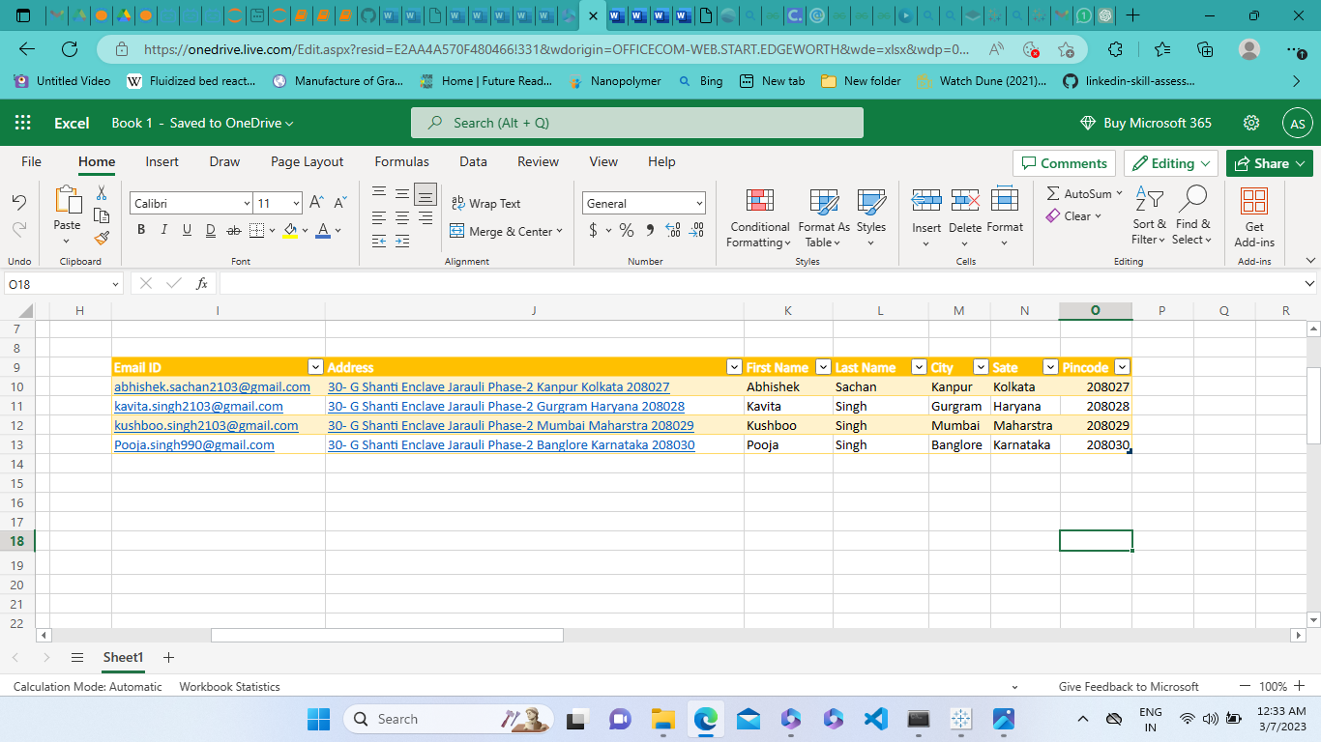

**3. What is freeze panes and why do we use freeze panes? Give examples.**

Freeze Panes is a feature in Microsoft Excel that allows you to freeze certain rows or columns in place so that they remain visible while you scroll through a large worksheet. It can be useful when working with large amounts of data, allowing you to always keep important headings or labels in view.

* Freezing the top row: If you have a large dataset with many rows of data, it can be helpful to freeze the top row so that you can always see the headings. To do this, select the row below the row you want to freeze, go to the "View" tab in the Ribbon, and then click on the "Freeze Panes" button and select "Freeze Top Row".
* Freezing the first column: Similarly, you can also freeze the first column of a large dataset so that you can always see the row labels. To do this, select the column to the right of the column you want to freeze, go to the "View" tab in the Ribbon, and then click on the "Freeze Panes" button and select "Freeze First Column".
* Freezing both rows and columns: If you want to freeze both the top row and the first column, select the cell below the row and to the right of the column you want to freeze, go to the "View" tab in the Ribbon, and then click on the "Freeze Panes" button and select "Freeze Panes".

Using Freeze Panes, you can make it easier to navigate large datasets and always keep important headings or labels in view. It can be especially useful when presenting data to others or when working on complex spreadsheets with many rows and columns of data.

**4. What are the different features available within the Freeze Panes command?**

1. Freeze Top Row: This feature allows you to freeze the first row of your worksheet, which is useful when you have a long list of data, and you want to always see the column headings. To use this feature, select the row below the row you want to freeze, go to the View tab, click on Freeze Panes, and then click on Freeze Top Row.
2. Freeze First Column: This feature allows you to freeze the first column of your worksheet, which is useful when you have a long list of data, and you want to always see the row headings. To use this feature, select the column to the right of the column you want to freeze, go to the View tab, click on Freeze Panes, and then click on Freeze First Column.
3. Freeze Panes: This feature allows you to freeze specific rows and columns simultaneously. This is useful when you have a long list of data, and you want to always see both the column headings and the row headings. To use this feature, select the cell below the row and to the right of the column you want to freeze, go to the View tab, click on Freeze Panes, and then click on Freeze Panes.

**5. Explain what the different sheet options present in excel are and what they do?**

* Rename: This option allows you to rename the sheet to a custom name that is easier to remember and recognize. To do this, right-click on the sheet tab at the bottom of the screen and select "Rename."
* Insert: This option allows you to insert a new sheet into the workbook. To do this, right-click on the sheet tab at the bottom of the screen and select "Insert."
* Delete: This option allows you to delete the selected sheet from the workbook. To do this, right-click on the sheet tab at the bottom of the screen and select "Delete."
* Move or Copy: This option allows you to move or copy a sheet from one location to another within the same workbook or to another workbook. To do this, right-click on the sheet tab at the bottom of the screen and select "Move or Copy."
* Protect Sheet: This option allows you to protect the sheet from being modified by unauthorized users. You can choose to password protect the sheet, prevent users from making changes to the formatting or contents, and more. To do this, right-click on the sheet tab at the bottom of the screen and select "Protect Sheet."
* Tab Color: This option allows you to change the color of the sheet tab to make it easier to identify and distinguish from other sheets in the workbook. To do this, right-click on the sheet tab at the bottom of the screen and select "Tab Color."